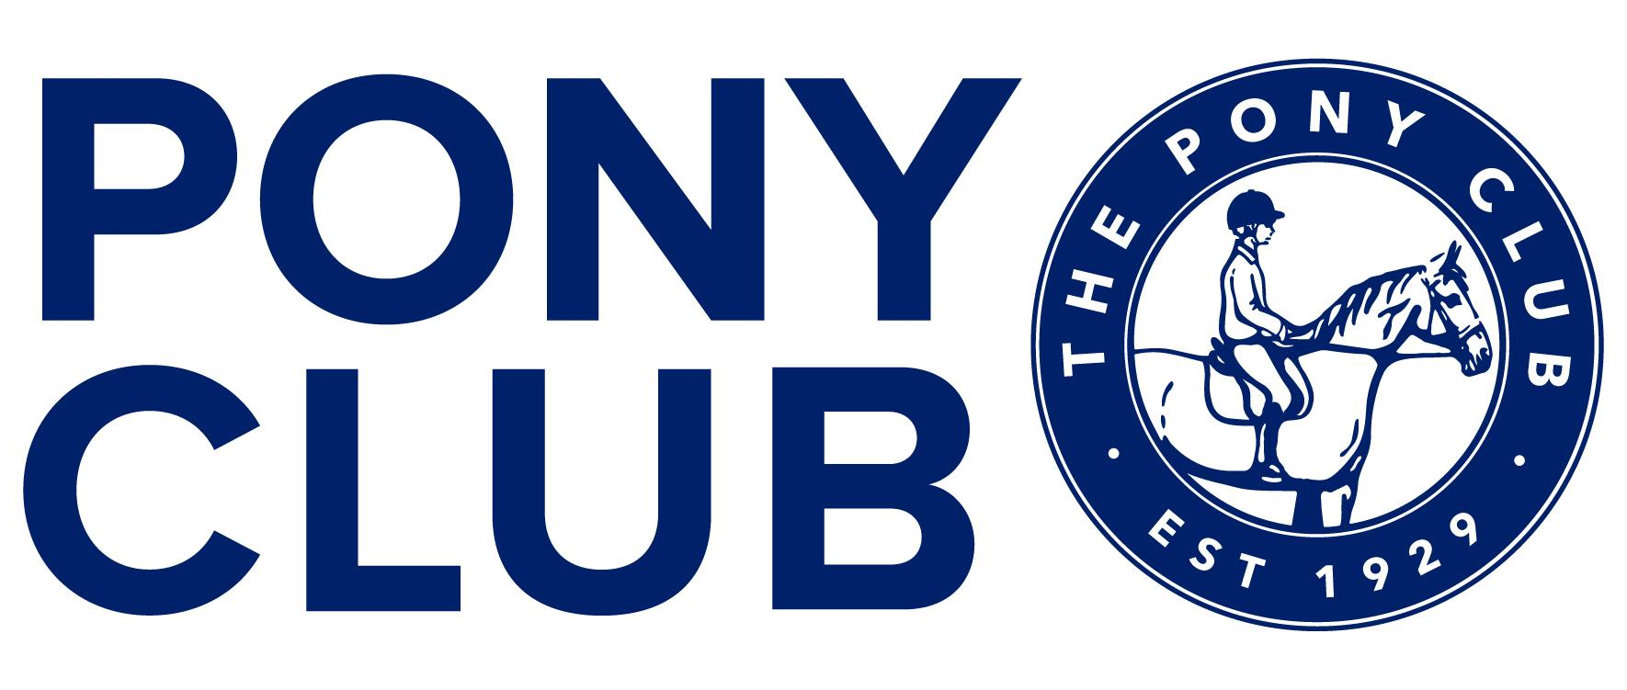
THE GARTH SOUTH BRANCH OF THE PONY CLUB

AREA 13 TEAM AND INDIVIDUAL SHOW JUMPING QUALIFIERS FOR
THE JCB PONY CLUB NATIONAL CHAMPIONSHIPS 2024
(9TH-17th AUGUST 2024 AT OFFCHURCH BURY)

Sunday 21st July 2024
Wellington Riding, Heckfield, RG27 0LJ

Area PC110 (Open) Show Jumping Competition

Area PC100 (Intermediate) Show Jumping Competition

Area PC90 (Novice) and Open PC90 (Novice) Show Jumping Competition

Entries open: 12th June 2024

Entries close: 30th June 2024

Organisers: Amanda Cottingham for Garth South Branch of The Pony Club

Course builder: Jenny Naylor-Davis

Online entries: Horse Events

ENTRIES CAN ONLY BE MADE BY THE DC/CENTRE PROPRIETOR/TEAM MANAGER NOT INDIVIDUALLY

Entries Secretary: Fi Miller garthsouthsecretary@gmail.com

Times and live scoring: Pony Club Results

Mobiles (ON THE DAY ONLY): will be advised to DCs / Team Managers nearer to the competition

Photography: MH Photos

NB two rounds per class

Class 1 PC110 (OPEN) AREA SHOW JUMPING COMPETITION
Entry fee: £40 each + £5 supplement per team
Open to Teams and Individuals
Start height of max 1.10m in first round

Class 2 PC100 (INTERMEDIATE) AREA SHOW JUMPING COMPETITION
Entry fee: £40 each + £5 supplement per team
Open to Teams and Individuals
Start height of max 1m in first round

Class 3 PC90 (NOVICE) AREA SHOW JUMPING COMPETITION
Entry fee: £40 each + £5 supplement per team
Open to Teams and Individuals
Start height of max 90cm in first round

Entry fees include first aid. All entries are subject to a non-refundable booking fee which will be stated online on a per class basis.

Useful Information

- All classes will run on a surface.
- Teams will run in a drawn order which will be the same for the first two rounds.
- Should weather conditions dictate and unless it is necessary to decide on qualifying places, the organisers reserve the right (in consultation with team managers) to waive the jump off.
- Numbers in the warm-up will be limited. Please do not enter the warm-up
arena until you have been invited to by the steward.
- There will be a tack and dress check; please allow 15 minutes for this before your
warm-up.
- Don’t forget your Pony Club badge and tie or stock and hats must be tagged!
- Start times and numbers will be available from 18th July 2024 on Horse Events

Rosettes
1st to 6th for individuals plus teams

Entry Amendments
If you would like to edit your horse or rider details before the closing date 30th June 2024 please login to your Horse Events account and edit your booking.

For ALL horse and / or rider substitutions after the closing date – the DC / Centre Proprietor or Branch/Centre Secretary / Team Manager (on behalf of the DC) should email education.garthsouth@gmail.com

For information about withdrawals and refunds please see rules and conditions of
entry below.

AMENDMENTS AND SUBSITUTIONS CAN BE MADE ONLY WITH PERMISSION FROM DC/CENTRE PROPRIETOR/TEAM MANAGER.

RULES AND CONDITIONS OF ENTRY

Entries are accepted and admission granted only subject to the following conditions, which are
deemed to have been accepted by each competitor:

1. The competition will be run in accordance with the Pony Club Show Jumping Rules 2024.
2. There will be an unmounted prize giving after each class. Prize winning competitors are expected
to be properly dressed as for competition for the prize giving.
3. All hats to be worn in the competition must be tagged with the pink tag. Hats must conform
to the current Pony Club standards and must have a chinstrap fastened at all times when
Mounted.
4. Competitors should familiarise themselves with changes to the whip rule for 2023 onwards
which will be strictly enforced, along with the Pony Club dress code.
5. No jewellery may be worn. If earrings cannot be removed, they must be taped.
6. Protest and Objections: Please see the Pony Club Show Jumping Rule Book 2024.
7. In the event of cancellation refunds will be processed by Horse Events.
8. Refunds (less an administration charge of £10) will only be given on withdrawal prior to the closing date. Withdrawals after the closing date will not be refunded.
9. In the event of the competition being abandoned a refund of 75% will be given.
10. Late entries will be accepted only at the discretion of the organisers and will be subject to a £5
late entry fee.
11. All dogs should be kept on a short lead at all times and must remain in the car park area. Please
clear up after your dog.
12. Horses/ponies competing may only be ridden at the venue by the Member who is entered to compete on them. Competitors must display their competition number at all times when mounted.
13. Horses / Ponies may only be tied up to a horsebox or trailer if an adult is standing next to the horse / pony. Competitors who leave their horses / ponies unattended (even to change in the lorry or fetch something) are, at the discretion of the Garth South DC / The PC Steward, subject to elimination. Please clear up all hay and droppings from around your trailer/horse box. Please do not tie hay
nets to the side of trailers/horse boxes.
14. All horses and ponies must be vaccinated as per Pony Club rules and checks will be
undertaken, so please ensure passports are available.
15. All horses and ponies, when outside the arena and warm up areas, should be ridden at walk only
to ensure the safety of all spectators and pedestrians.
16. Smoking is prohibited anywhere on site
17. The organisers reserve the right to refuse any entry without stating a reason for doing so and
also reserve the right to eliminate any competitor who in their opinion places her/himself or
others in danger or fails to observe rules.

DISCLAIMER:
Save for the death or personal injury caused by the negligence of the organisers, or
anyone for whom they are in law responsible, neither the organisers of this event or The Pony Club
nor any agent, employee or representative of these bodies, nor the landlord or his tenant, accepts any
liability for any accident, loss, damage, injury or illness to horses, owners, competitors, spectators or
any person or property whatsoever, whether caused by their negligence, breach of contract or in any
other way whatsoever. Entries are only accepted on this basis. The organisers of this event have
taken all reasonable precautions to ensure the health & safety of everyone present at this event. For
these measures to be effective everyone must take reasonable precautions to avoid and prevent
accidents. They must obey the instructions of the organisers and all officials and stewards.

REASONABLE ADJUSTMENT:
The Pony Club is committed to ensuring that, wherever possible, members are able to access all aspects of the Branch and Centre activities we offer. Reasonable Adjustments are any actions that help to reduce the effect of a disability or difficulty. Any requests for Reasonable Adjustment must be made to the Secretary garthsouthsecretary@gmail.com by 30th June 2024.

PHOTOGRAPHIC RIGHTS:
Competitors and their guardians give permission for any photographic
and/or film or TV footage taken of persons taking part in Pony Club events to be used and published
in any media whatsoever for editorial purposes, press information or advertising by or on behalf of
The Pony Club and/or official sponsors of The Pony Club. If an individual wishes to withdraw this right, the parent, Member (if 18 or over) or a Branch Official should notify the Secretary garthsouthsecretary@gmail.com

