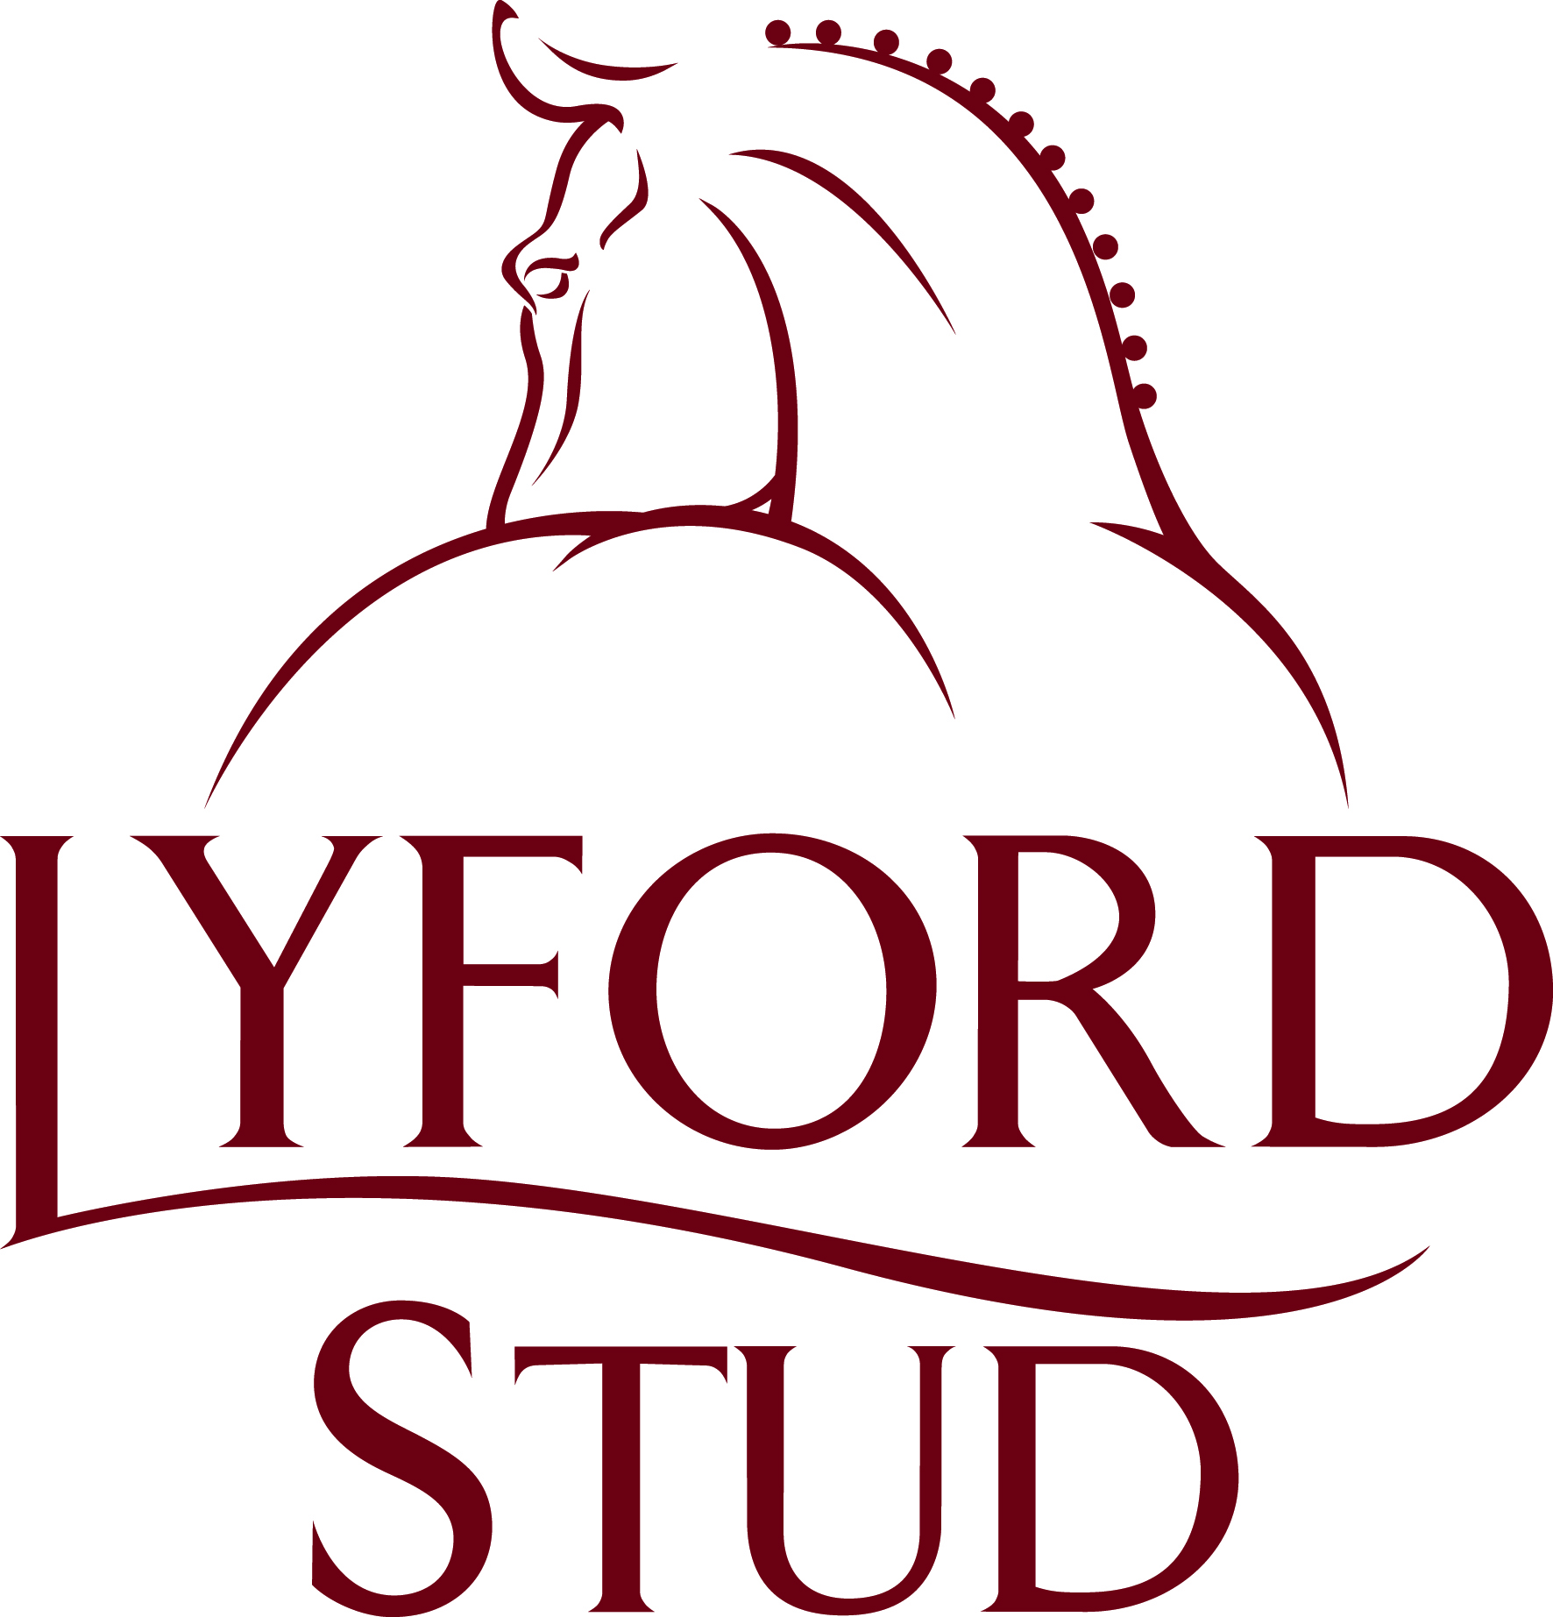

**ONE DAY EVENT**

Sunday 1st September 2024

Saturday 5th October 2024

At LYFORD STUD

Northmead Lane

Charney Bassett

OX12 0HB

Carol 07831 165373

[equinavetuk@gmail.com](mailto:equinavetuk@gmail.com)

Please enter via [www.horse-events.co.uk](http://www.horse-events.co.uk/)

**Sunday 1st September 2024**

**CLASS 1**

Dressage – Pony Club Walk and Trot Dressage Test 2022

<https://pcuk.org/media/fgrahlau/walk-trot-2022.pdf>

Showjumping - max height 40cm

Cross country – approx. height 40cm

*(There are no restrictions on tack for the dressage phase. Lead rein and assistance may be given in dressage and/or jumping phases. Class will be split (12yrs and younger/over 12yrs if entries allow)*

Entry fee - £60

**CLASS 2**

Dressage – Preliminary Pony Club 70 Dressage Test 2022

<https://pcuk.org/media/axthkcvp/preliminary-pc70-2022-test-sheet.pdf>

Showjumping - max height 60cm

Cross country – approx. height 60cm

Entry fee - £70

**CLASS 3**

Dressage – Horse Events Dressage Test 80C 2023

<https://www.horse-events.co.uk/wp-content/uploads/2023/06/HE-Unaff-80-Dressage-Test-C-2023-FV.pdf>

Showjumping - max height 80cm

Cross country - approx. height 80cm

Entry fee - £70

**Saturday 5th October 2024**

**CLASS 1**

Dressage - Pony Club Walk and Trot Dressage Test 2022

<https://pcuk.org/media/fgrahlau/walk-trot-2022.pdf>

Showjumping - max height 40cm

Cross country – approx. height 40cm

*(There are no restrictions on tack for the dressage phase. Lead rein and assistance may be given in dressage and/or jumping phases. Class will be split (12yrs and younger/over 12yrs if entries allow)*

Entry fee - £60

**CLASS 2**

Dressage – Preliminary Pony Club 70 Dressage Test 2022

<https://pcuk.org/media/axthkcvp/preliminary-pc70-2022-test-sheet.pdf>

Showjumping - max height 60cm

Cross country – approx. height 60cm

Entry fee - £70

**CLASS 3**

Dressage – Horse Events Dressage Test 80C 2023

<https://www.horse-events.co.uk/wp-content/uploads/2023/06/HE-Unaff-80-Dressage-Test-C-2023-FV.pdf>

Showjumping - max height 80cm

Cross country - approx. height 80cm

Entry fee - £70

**Dressage tests may be called**

**We will not be using our number bibs, competitors are asked to print their own numbers and provide their own bibs**

Rosette’s 1st – 6th place

Entries close Weednesday before the event.

Times available Thursday before the event (on Lyford Stud Facebook page or phone 07831 165373 between 7-9pm)

**RULES AND REGULATIONS OF ENTRY**

1. It shall be deemed a condition of entry that the organisers, the landowner or his agents shall not be held responsible for any loss, injury or damage to competitors, onlookers or their property, how so ever caused.
2. Vaccinations to be within 12 months of competition date
3. Correct attire, including a hard hat to current safety standards, must be worn at all times when mounted.
4. Body protectors are compulsory and must be within current safety standards for XC phase
5. The organisers reserve the right to cancel the show, alter classes, judges, time or any of the published information.
6. Horses, ponies and riders must be 4 years and over.
7. No horses, ponies or children to be left unattended.
8. Please clear up any droppings/hay by lorry/trailer prior to leaving.
9. No lunging
10. No dogs.
11. It is a deemed a condition of entry that all competitors have inspected the ground/surface prior to entering and are happy to proceed.
12. Numbers will be strictly limited
13. All riders have assessed the courses and have entered a class they deem within their capabilities.