Little Margate Equestrian Pony Club Mounted Games Training Day

Monday 08 April 2024

**Colraine Equestrian Centre**

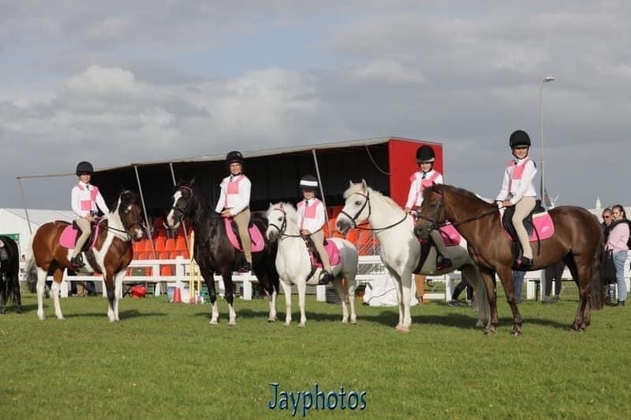

A fun filled training day. The day is designed to give the new and less experienced riders confidence in games and to find out how much fun can be had. Also, a brilliant opportunity for more experienced riders to improve their skills, meet other games riders and get ready for the upcoming Area competition.

The invite is for Centre and Branch members, you don’t need to have a team to enter, we can group people if required. If you are entering as a team, please email [littlemargateequestrian@outlook.com](mailto:littlemargateequestrian@outlook.com) with team member names.

Lead Reins Welcome!

Each team/club will need to bring their own equipment.

Entries will be taken via horse events.

£30 per person.

Any queries please email [littlemargateequestrian@outlook.com](mailto:littlemargateequestrian@outlook.com)