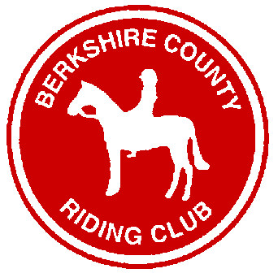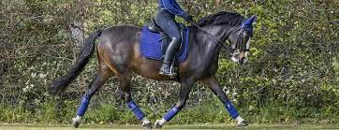
Berkshire County Riding Club
Matchy Matchy Dressage Competition
Open Outdoor Unaffiliated Dressage

23rd June 2024
Fairoak Grange, Ashford Hill, Berkshire, RG19 8BL
By kind permission of Lindsey and Peter Dawes
Rosettes to 6th place in each class and section
Rosettes to 3rd place in each class and section for best “Matchy Matchy”
Light refreshments supplied by “Pony Stars”
Photographer for the day is Emily Corten of www.corteninthemoment.co.uk
Raffle in aid of Thames Valley Air Ambulance
Dressage entries close on the Monday before the event.
Dressage times will be published on the Thursday before the competition on the website: www.berkscountyridingclub.co.uk and BCRC Facebook page.
Entries Secretary – Horse Events, info@horse-events.co.uk or Jo Lake, berkshirecountyridingclub@gmail.com or 07775 625310‬.
ENTER ONLINE AT www.horse-events.co.uk. If you have any queries regarding online entries, please contact Horse-Events 07962 251696 OR info@horse-events.co.uk
CLASS 1 | Pick Your Own Test  Prelim 18 (2002)  Novice 27 (2007) | Please select Senior or Junior 18 and under  Please state which test on entry form
CLASS 2 | Pick Your Own Test  Novice 40 (2009)  Elem 44 (2002) | Please state which test on entry form
CLASS 3 | Intro C (2016) | Please select Lead Rein or Junior under 16 or Senior 16 and over
CLASS 4 | Prelim 12 (2005) | Please select Senior or Junior 18 and under
“Matchy matchy” is not compulsory however, competitor numbers should be worn.
Entry Fees (on-line) – Full schedule with Rules online
 | BCRC Member | Non-Member
Dressage per class | £18 | £21
Booking Fee per class | £1.45 | £1.45
Please note all entries are subject to a non-refundable booking fee which will be stated online on a per class basis. If the competition has to be cancelled the entry fee will be refunded minus a £2.50 admin fee. No refunds after the closing date unless the event has been cancelled. Classes will close early if full.

